Bibliographic details

Thin
Word query

Phrase query
AddKey query
Quick query

Sort
Collocation
Query Builder
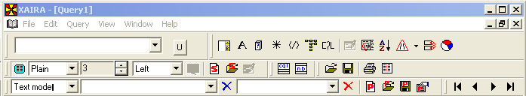
Analysis
Page/line mode
Format
Partitions
Flybys
Scope
Activate region
Activate class
Edit
Navigation
Edit Query

